Allworx
Installation Planning Guide


-PAGE INTENTIONALLY LEFT BLANK-
Table of Contents
Customer Site Survey 1
Part 1 – EMPLOYEE and Location Information 2
Part 2 – Phone System 3
Voice Service Delivery 3
Current Phone System 4
Allworx System Configuration 5
Allworx Phone Definitions 10
Allworx 9112 Phone Configuration 12
Allworx 9102 Phone Configuration 13
Part 3 – IT Environment 14
Part 4 – Allworx Client Application 16
User Workstations/OS/Apps 16
Part 5 – Physical Infrastructure 17
Part 6 – Documentation 18

Customer Site Survey

Customer Information
Note: Affix Contact’s business card here, if available:

Company Name:

Primary Contact/Title:

Address:

Phone/Fax Number:

E-mail Address:

Company Website URL:

Business Type:

Part 1 – EMPLOYEE and Location Information
- Number of locations:

- Address of locations:

- Number of Employees:

- Client Information: Please list Employee Information, including name and title, contact information, and e-mail address:

- Are there multiple offices - Will you be interconnecting locations using our site-to-site feature (requires multiple Allworx® Servers and a VoIP key)?

- Are you going to have remote users or satellite offices (Requires multiple Allworx Servers and a VoIP key)?

- What is your current site-to-site connection method (for example, VPN)?

Part 2 – Phone System

Voice Service Delivery
- Who currently is your supplier for Voice Service?

- How is the current voice service delivered from your provider (for 24x T1 service, list the type of T1 connection: PRI, CASS, Fractional)?

- Do you currently send your voice over the Internet (VoIP, i.e., Vonage, CallVantage)?

- If so, who is your Internet Telephony Service Provider (ITSP)?

- How many outside lines (also known as Central Office Lines) do you currently have?

- How are the lines provisioned (DID, Inbound vs. Outbound)

- What features do you get from your telephone service provider?

- How many Fax Lines do you currently have?

- How many Alarm Lines do you currently have?

- Will the Fax or alarm lines be connected through the Allworx server?

Current Phone System
- What is the manufacturer and model number of your current phone system (for example, Toshiba, Nortel, etc.)?

- When did you purchase your existing system?

- What do you like about your current system?

- What do you dislike about your current system?

- Who is the manufacturer and what is the model number of your phones (handsets)?
Note: Proprietary handsets are not reusable in the Allworx system.

- How many phones do you currently have?

- What is the manufacturer and model number of your Wireless and Cellular phone?

- How many Wireless/Cellular phones do you currently have?

- How do you currently answer incoming calls (for example, Live Answer, Auto Attendant, etc)?

Allworx System Configuration
- Describe how incomings calls will be handled during business and after hours. (Use diagram on following page).

- How many users/extensions will be required?

- How many system extensions such as Conference rooms, Lobby phones, etc. will be required?

- What is the total number of phones required?

- Are there special handset restrictions required (private lines or separate businesses)?

- Do you need to control the order/sequence outside lines are used?

- Are there any Local Area Code dialing requirements (7, 10, or 11 digits)? If so, please specify:

- Do you have a door relay (Allworx 6X and 24x only)? Do you have an outside door phone; does it require a trunk or station port on the PBX?

Phone System Features
Feature | Current System  Yes/No | Desired  Yes/No
Auto Attendant
Call detail records
Call Park/Retrieve
Call Transfer (Blind/Attended)
Call Waiting
Caller ID
Conference Calling
Group Extensions/mailboxes. such as sales, service, etc.
Handset-Handset(s) paging
Multiple Auto Attendants
Music On-Hold/Custom On-Hold messages
Overhead Paging
Restricted outbound calling
Shortcuts from Auto Attendants – single digit shortcuts such as sales, support, billing, etc.
Voice Mail for users/# of ports

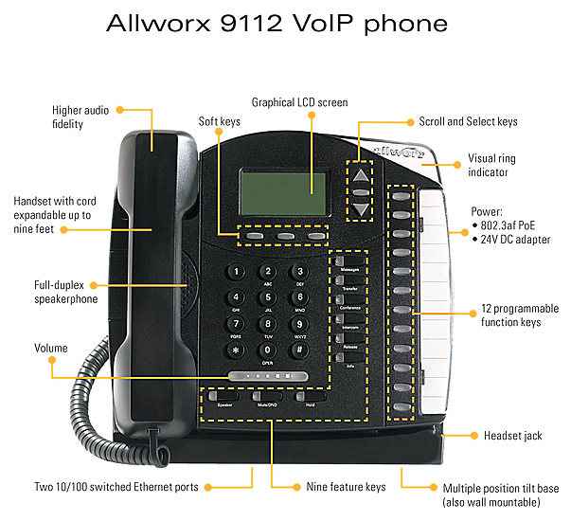

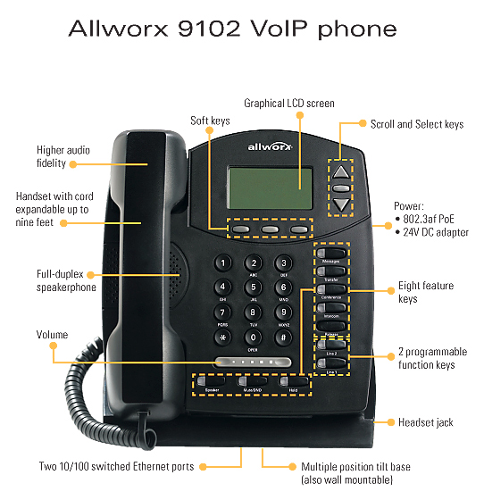

Allworx Phone Definitions
Softkey – A button that changes function depending on what you are doing with the phone. The current function is highlighted using a keyword immediately above the button on the phone’s LCD screen. This helps in simplifying the use of the phone.
Programmable Feature Keys (PFKs) – These are the buttons that will be programmed by your System Administrator in the configuration that best suits your needs. The 9112 model has twelve programmable buttons; the 9102 model has two programmable buttons. The following definitions, describe how each button can be configured.
Line Appearance – When defined as a Line Appearance button, the user has the ability to monitor a specific outside line (FXO/DID loops). With an incoming call, all the users monitoring that specific outside line will have their phones ring. Unless you use the Hold function, selecting another line appearance line means that you will hang up on the first Line Appearance call. This is typically a Key System function. Line Appearance has a Ring Type associated with it and must be specified.
Ring Type – Allworx phones can ring with different patterns and tones. Ring Types are associated with Line Appearance and Call Appearance and must be specified.
- No Ring
- Single Ring
- Double Ring
- Ring Type 1 – Single Ring Tone B
- Ring Type 2 – Double Ring Tone B
- Ring Type 3 – Single Ring Tone C
- Ring Type 4 – Double Ring C
- Ring Type 5 – Single Ring Tone D
- Ring Type 6 – Double Ring Tone D
Direct Station Selection/Busy Lamp Field (DSS/BLF) – When defined as a DSS/BLF button, you will have the ability to connect to another user’s phone using the intercom channel and the ability to monitor the status of that user’s phone.
Note: In order for this button to work in DSS/BLF mode, the System Administrator must select Key System Mode when configuring the buttons.
Speed Dial/Busy Lamp Field – When defined as a SD/BLF button, you will have the ability to ring another user’s extension and the ability to monitor the status of that user’s phone.
When the phone is in PBX mode the BLF will act as a Speed Dial, and when in Key System Mode the PFK will act as Direct Station Selection.
Note: In order for this button to work in SD/BLF mode, the System Administrator must select PBX Mode when configuring the buttons.
Speed Dial – When defined as a Speed Dial button, you will have the ability to use a shortcut key to ring any number whether it’s a personal number or business extension set up by the System Administrator.
Call Appearance – When defined as a Call Appearance button, you will have the ability to receive calls targeted for your extension. You may have multiple buttons configured for Call Appearance, which you can manage individually. For example, each call can be put on hold or transferred to another extension. Call Appearance has a Ring Type associated with it. Please see the description above for the Ring Types.
Function– A programmable button can be defined as a Function with the choices being Centrex Flash, Headset, Personal Speed Dial, and Redial. When defined as line flash, you can directly flash an outside phone line to access services provided by your phone company, such as call forwarding, conferencing, etc.
Headset – When defined as a Headset function, this button will allow you to transfer your conversation to a headset if connected.
Personal Speed Dial – When defined as a Personal Speed Dial function, this button will call your personal contacts, such as home, a supplier, or customer. The user, within the Configuration menu on the phone defines Personal Speed Dial numbers.
Redial – When defined as a Redial function, this button will redial the last call made by the user.
Not Used – When defined as Not Used, this button will not be usable by the user.

Allworx 9112 Phone Configuration
Employee Name: ______________________
Employee Location: ____________________

INSTRUCTIONS
Place an X in the PFK number column that describes the selection for that PFK. This worksheet should be filled out for each user.
Note: There can only be one selection per PFK button.
SELECTION | PFK #12 | PFK #11 | PFK #10 | PFK #9 | PFK #8 | PFK #7 | PFK #6 | PFK #5 | PFK #4 | PFK #3 | PFK #2 | PFK #1
BLF (PBX Mode or Key System Mode)
Call Appearance (include Ring Type)
Line Appearance (include Ring Type)
Function (Select one of the following)
Centrex
Headset
Personal Speed Dial
Redial
Queue Appearance (0 - 9)
Parking Orbit (701 - 709)
Speed Dial
Not Used

Allworx 9102 Phone Configuration
Employee Name: ______________________
Employee Location: ____________________
INSTRUCTIONS
Place an X in the PFK number column that describes the selection for that PFK. This worksheet should be filled out for each user.

Note: There can only be one selection per PFK button.
SELECTION | PFK #2 | PFK #1
BLF (PBX Mode or Key System Mode)
Call Appearance (include Ring Type)
Line Appearance (include Ring Type)
Function (Select one of the following)
Centrex
Headset
Personal Speed Dial
Redial
Queue Appearance (0 - 9)
Parking Orbit (701 - 709)
Speed Dial
Not Used

Part 3 – IT Environment
Use the Network Topology diagrams as discussion points and examples of typical configurations, and attach to survey.

- Who services your network?

- Who is your Internet Service Provider?

- What type of connection to your site?
  - T1 (note the T1 data type: PPP), DSL, Cable Modem

  - What is the Speed and Bandwidth?

- What is the manufacturer and model of your modem/IAD?

- Addresses from ISP (please note if more than one)
  - Static IP address
  - Subnet Mask
  - Primary & Secondary DNS servers

- Do you have any network devices (Firewall, Router, or Switch)?

- If so, what are the manufacturer and model numbers?

- Please diagram the network topology.

- What is the Network Server for DNS/DHCP?

- Who hosts your website?

- What is the format of your website (FrontPage, Coldfusion, etc.)?

- Where is your e-mail hosted and how do you currently receive you mail?

- What is the number of e-mail users?

- Will you use Allworx as your primary mail server or web site host?

- Are there any other Servers/Applications?

- Will Allworx be the main gateway to the Internet or will it be a device on another network?

- Main Router/Firewall
- Host on LAN

Part 4 – Allworx Client Application
The Allworx Calendaring Tool gives users the ability to have Calendaring, Unified Messaging, and Contacts.

The Calendar function allows you to create and manage your business and personal activities, events, and meetings.

The Contacts function allows you to create and manage your personal contacts, contact groups, and access company contacts.

The Unified Messaging allows you to access and manage your voice and e-mail in one inbox. Unified Messaging requires the use of a messaging POP3 compatible e-mail client tool, such as the Allworx Client Mail tool, Microsoft Outlook Express™, Microsoft Outlook™, or Lotus Notes™, and a media player, such as RealAudio™, Liquid Audio™, or Microsoft Player™ (format of audio is .wav), along with a functioning audio card and speakers.

Note: A majority of Allworx customers leverage their existing E-mail client rather than porting all their data into the Allworx E-mail client.

User Workstations/OS/Apps
- What is the total number of Workstations?

- What are the Vendor and OS versions (such as Windows XP or Windows 2000)?

- What is the current PC/Workstation Hardware including RAM, Disk Space, Network Interface Card?

- What is the current Browser Software?
Note: Allworx Clients are compatible with Windows 2000, 2003 and XP; Administration can be done via any web browser.

- It is highly recommended that the system is periodically backed up using the Allworx OfficeSafe application. Which PC will be used for the OfficeSafe backup?

- Will the customer be using the Allworx Call Assistant application?

Part 5 – Physical Infrastructure
- Where will the Allworx unit be installed?
Note: The Allworx 10x and 24x units can be installed in a 19” rack, wall, or tabletop mounted.
The Allworx 6x unit can be installed on a wall or tabletop mounted.

- Where is the Demarcation Location (Point of phone service delivery)? For T1 service, where will the DSX-1 interface from the telephone company be located?

- Will new wiring be required?
Note: Allworx requires RJ-11 two wire, center pair plugs for all analog telephony connections.

- Does any existing wiring need to be re-located?

- Will new wiring be required for Network or VoIP Phones?
Note: Allworx requires CAT5 or better cabling for Network devices.

- Is adequate backed up power available (separate breaker recommended with some form of UPS)?

Part 6 – Documentation
Documentation and software are available at:
http://www.allworx.com

Completed
Name: _____________________________ Date:__________________________
Approved
Name: _____________________________ Date:__________________________

