

AltiTouch Plus Installers Guide

Notice

While every effort has been made to ensure the accuracy, Sayson Technologies, Inc. will not be liable for technical or editorial errors or omissions contained within this documentation. The information contained in this document is subject to change without notice.

Trademarks

AltiGen, AltiWare, AltiMail, AltiServ, and AltiAdmin are registered trademarks of AltiGen Communications. All other brand names, product names or company names mentioned are trademarks or registered trademarks of their respective companies and are hereby acknowledged.

Copyright

Copyright © 2001 All rights reserved. The manual and the products described in it are copyrighted with all rights reserved. The AltiTouch Plus software is furnished under a license agreement. Neither this documentation nor the software described in it may be copied, photocopied, back-engineered, reproduced, translated, modified or reduced to any electronic medium or machine-readable form, in whole or part, without the prior written permission of AltiGen Communications.

Contents

Warranty 1

System Requirements 3

Introduction 4

Installation 6

Configuration 8

Advanced Configuration 12

AltiWare Configuration 14

Trouble Shooting 15

Warranty:

Limited Warranty on Software:

The Software will perform substantially in accordance with the accompanying written materials for a period of sixty (60) days from the date of receipt. Any implied warranties on the Software are limited to sixty (60) days. Some states/jurisdictions do not allow limitations on duration of an implied warranty, so the above information may not apply to you.

Warranty on Hardware:

There is a one (1) year warranty for any defective AltiTouch 390 or AltiTouch Plus phone from the time of purchase. Return of product that is not authorized or deemed to be functioning correctly, may be subject to a 20% restocking fee.

What the Warranty Covers:

- Protects only the first end user purchases for the first year.
- Product that is deemed to be defective or malfunctioning by Sayson Technologies. (See "How to Return Defective Product" for more details).
- Cost of repair for verified defective product.
- Cost of shipping if, and only if, within the first thirty (30) days from time of purchase.

What the Warranty Does Not Cover

- Product that is returned incomplete or without all its parts and original packaging and manuals.
- Product that has been damaged, or is malfunctioning due to:
  - Misuse, unauthorized modifications to the product or tampering of any kind.
  - Accidental causes such as damages relating to water, fire, lightning, power surges, power outages or general neglect.
  - Product damaged during shipping.
  - Any attempted repairs by unauthorized persons.
  - Tampering to the service or software, including downloading any additional or conflicting services or software that may affect the functioning of the product.
  - Failure to follow instructions.
  - The use of parts from other products such as power supplies that may not be compliant with those products specifications.
  - Everyday wear and tear of that product, or any other cause not relating to a product defect.

System Requirements:

Software:

- AltiGen's AltiWare OE Rev. 4.0a (4.0.2.11 or greater) installed and running.

(For versions of AltiWare OE Rev. 4.0a that are prior to version 4.0.2.11, please contact your AltiGen dealer or AltiGen Communications on how to upgrade to version 4.0.2.11.)

- AltiTouch Plus software installed, registered and running on the AltiGen Server.

(AltiTouch Plus software is free, but must be registered at www.sayson.com/webpages/companyinfo.htm where you will receive a free license number after registering in order to activate the program.)

- AltiWare Administrator must have the "Loop Current Break Duration" under the "line properties" button extended to 750ms in order to use the intercom feature. It must be extended on extensions receiving and on extensions sending Intercom calls.

Approved Hardware:

- AltiGen 12 port PCI Analog Station Board (ALTI-TTAS-12) requirements of the AltiTouch Plus phone for the Intercom feature.

Also see requirements for AltiWare. Requirements for AltiWare 4.0 can be found in AltiGen's AltiWare 4.0 Getting Started Manual.

Introduction

About This Guide:

Welcome to the AltiTouch Plus Installer’s Guide. This guide describes the functions and features of the AltiTouch Plus program. It also explains how to install, configure, and use the software

About The AltiTouch 390 Screen Phone:

The AltiTouch 390 has been custom programmed and certified for use with the AltiGen Phone System. The customization to this phone gives you quick and easy access to many of the most common and powerful AltiGen features. Because the AltiTouch 390 is State Sensitive (state meaning the Connected State when off-hook, and Idle State when on-hook), it displays only the relevant options you would require for that particular state. The most commonly used features are more readily accessible in first or second level menus. You can access these features or lower level menus by pressing one of the 6 soft key buttons positioned around the phone’s large display.

About The New AltiTouch Plus:

The AltiTouch Plus is the same basic phone as the AltiTouch 390 with similar customization for the AltiGen System. However, the AltiTouch Plus is an enhancement of the original AltiTouch 390 phone. Through the AltiTouch Plus software, the phone interacts with your AltiGen System to give you Visual Voicemail, and Screen Based System Park Pickup. The AltiTouch Plus software is the free server side software for the interactive services of AltiTouch Plus phones. The AltiTouch Plus Graphical User Interface (GUI) allows you to control whether a user would like to have their Visual Voicemail, that gets displayed on the screen of their phone when they select this option, protected with their AltiMail password, or whether they would prefer this removed for quicker access into their Visual Voicemail box. It also gives you Intercom when AltiGen's 12 port PCI Analog Station Board (ALTI-TTAS-12) is installed.

About the Software:

The AltiTouch Plus program provides interactive services on the AltiTouch Plus phone. If this software is not installed and running, then your AltiTouch Plus phone will not be able to use the interactive features. Please see System Requirements for more details.

AltiTouch Plus

The AltiTouch Plus software is installed on the AltiGen telephony server and can run either as a service or an application. The GUI allows you to monitor and configure the Interactive Services for particular users. It also includes the AltiTouch Update patch for AltiWare 4.0a.

Installation

Getting Started

Prior to Installation, please check the following:

- AltiWare OE Rev. 4.0a (4.0.2.11 or greater) is installed and running.
- The installer is logged into the computer with local administrative rights.
- And for the intercom feature, AltiGen's 12 port PCI Analog Station Board (ALTI-TTAS-12) has been installed and configured.

Installing The AltiTouch Plus Program:

The AltiTouch Plus program should be installed into the same drive as AltiWare.

  - Insert CD into the CD-ROM drive.
  - Follow the instructions that appear on your screen
  - If the set-up program does not auto play, then double click on “setup.exe” on the CD to run the set-up.
  - AltiTouch Plus Server software MUST be installed in a directory whose path does not have spaces in the name, therefore, do not install this in the program files directory.

This installation includes the AltiTouch Plus Administrator software and the AltiTouch Plus Patch for AltiWare OE Rev. 4.0a. (4.0.2.11 or greater).

(For versions of AltiWare OE Rev. 4.0a that are prior to version 4.0.2.11, please contact your AltiGen dealer or AltiGen Communications on how to upgrade to version 4.0.2.11.)

AltiTouch Plus Registration:

When you first start your software you will be required to enter your registration number. To register your software, go to www.sayson.com/webpages/companyinfo.htm and fill in the AltiTouch Plus registration form. Please make sure you follow the instructions and fill in the required fields correctly. You MUST fill out the required fields correctly. As soon as you have completed this, submit the form. You will be e-mailed back a registration number to the e-mail address you provided in the form.

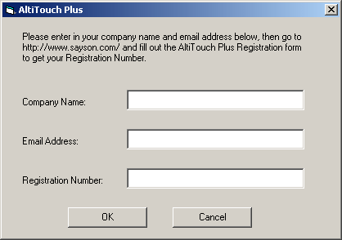

Go to the start menu and select the AltiTouch Plus program. When the registration screen appears, fill in your Company’s name, the e-mail address you provided upon registration, the Registration Number, and then press the “OK” button. If an error occurs, check to make sure there aren’t any added spaces before or after the registration number. Also check that the correct case (upper or lower) has been entered.

AltiTouch Plus Set-Up
- Go to the start menu and select the AltiTouch Plus program.
- Go to the Setup tab.

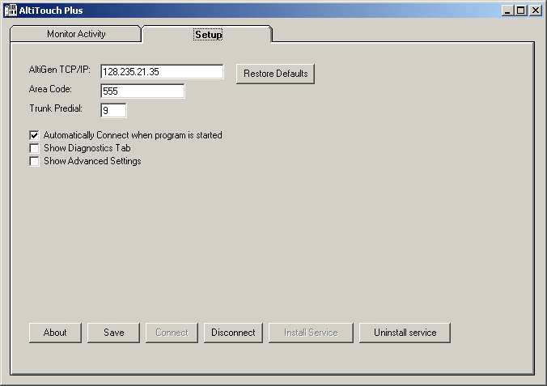

- In the Setup Tab, beside “AltiGen TCP/IP:” enter the TCP/IP address or name of the AltiGen Server.
- Beside “Area Code:” enter in your local 3-digit area code.
- Beside “Trunk Predial:” enter in the Trunk pre-dial used to dial out to get an outside line (usually 9).
- Press the “Save” button to save configuration. Important: you must save configuration before connecting.
- Press the ”Connect” button and go to the Monitor Activity Tab. If it has connected successfully, you should see a list of extensions (This could take up to 20 – 30 seconds, depending on the size of the phone system). To connect or disconnect from the AltiGen manually, press the “Connect” or “Disconnect” buttons.
- Under the Setup Tab, check the “Automatically Connect when program is started” checkbox to connect to the AltiGen automatically whenever the program was started.

Advanced Set-Up Tab Configurations:

In the Setup Tab, you can view and adjust additional configurations by clicking the “Show Advanced Settings” check box. Adjustments to these settings are Global changes that will affect all using the AltiTouch Plus in this system.

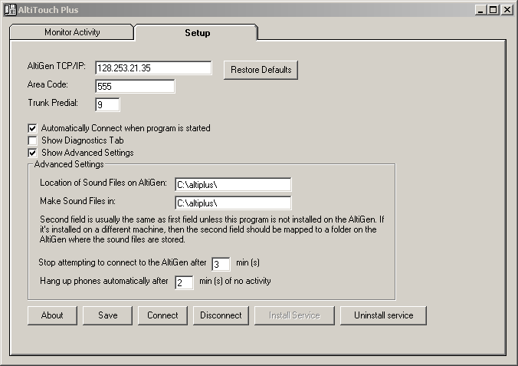

The “Stop attempting to connect to the AltiGen after __ min(s)” setting allows you to adjust the length of time the AltiTouch Plus software will attempt to connect to the AltiGen system before timing out. The default length of time is set to 3 minutes.

- The “Hang up phone automatically after__ min(s) of no activity” is a security setting that allows you to adjust the length of time allowed for an AltiTouch Plus phone to remain in either the Visual Voicemail (VMail+) or the Screen Based System Park Pickup (SysPark+).

Do not adjust the “Location of Sound Files on AltiGen:” setting, nor the “Make Sound Files in” setting, unless advised to by an AltiGen or Sayson Tech Support Representative.

Monitor Activity

Press the Monitor Activity Tab to access the “Monitor Ports:” and “Parked Calls:” activity. The administrator can adjust the “Get Passcode” and “Sorted by” fields here for individual users.
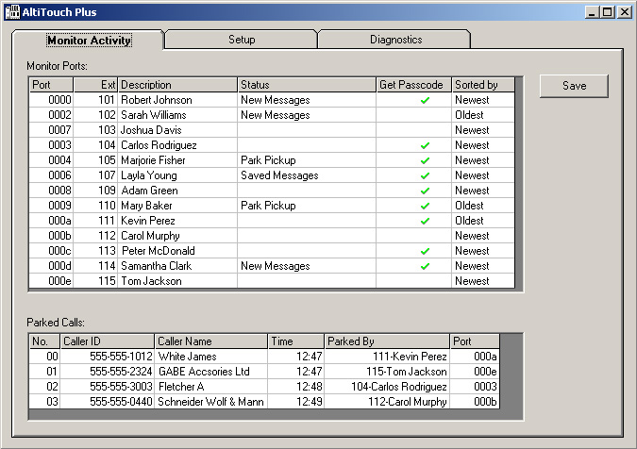

Monitor Ports

- The “Port” column refers to the AltiGen Port Number.
- The “Ext” column refers to the extension number (only shows extensions that have been logged into).
- The “Description” column refers to the name of extension user.
- The “Status” column shows what screen in the Interactive Service a user is accessing: “Password”, “New Messages”, “Saved Messages”, “Dialing Menu”, and “Park Pickup”.
- The “Get Passcode” column allows the administrator to adjust whether a particular user’s Visual Voicemail is password protected with their AltiMail password. If this is checked, their password will be required when accessing their Visual Voicemail. If it is unchecked, the user goes directly to the new messages screen. Select or deselect by double clicking in the row corresponding to the specific user, under the “Get Passcode” column.

- The “Sorted by” column allows the administrator to adjust the order in which voicemail messages appear to a particular user when accessing Visual Voicemail: “Oldest” meaning oldest messages displayed first, or “Newest” meaning newest messages displayed first.

Parked Calls:

- The “No.” column refers to the System Call Park Location Number of a parked call.
- The “Caller ID” column displays the *Caller ID number of the system parked call.
- The “Caller Name” column displays the *Enhanced Caller ID name of the parked call.
- The “Time” column refers to the time at which the call was System Parked.
- The “Parked By” column refers to the extension number and the first few letters of the name of the person who parked the call.
- The “Port” column refers to the AltiGen Port Number.

For any changes made on this tab, you must press the “Save” button for these changes to take affect.

If you are running this as a service you will need to stop the service and run this as an application in order to access the Graphical User Interface (GUI) to administer it. Stopping the service will temporarily disrupt the Screen Based System Park Pickup (SysPark+) and the Visual Voicemail (VMail+) features. However, the Intercom (Intrcom) feature will function regardless.

* Full functionality of some features assumes availability and customer subscription to service provider offerings.
Advanced Configurations

AltiTouch Plus as an NT Service:

This section assumes you are familiar with Windows NT services. To run AltiTouch Plus software as a service, you need to:

- Make sure AltiTouch Plus is properly configured to run as an application.
- In the Setup tab, make sure the “Stop attempting to connect to the AltiGen after __ min(s)” is set to a delay long enough for the AltiWare service to start.
- Check the box “automatically connect when program is started” in the Setup tab
- Click the button “Install Service”
- Close the application
- Open the services panel from your control panel
- Look for the AltiTouch Plus service and start it

Make sure the application is running by dialing #9401. If it’s running properly, you will be greeted with the password screen for your voicemail.

Diagnostics Tab

Your authorized AltiGen dealer or Sayson Tech support staff may ask you to access the diagnostics tab when troubleshooting. Do not clear any of the data unless asked to do so. The “Write all data to File” button writes data to 3 text files. You may be requested to do this and send a copy by Tech Support staff. For the most part, this tab is not used.

In the Setup Tab, check the “Show Diagnostics Tab” check box and press the Diagnostics Tab to get to the Diagnostics screen

AltiWare Configuration

In order to use the intercom feature, you will need to reconfigure extensions that will be using the intercom feature to receive an intercom call. To do this, follow the instructions below:

- Go to AltiWare Administrator.
- Double click on an extension to get the Extension Configuration.
- Under the “General” tab, select the “Line Properties” button.
- Extend the “Loop Current Break Duration” time to 750ms.
- Select “Apply to..” to apply this to more than one extension at a time.
- Press “OK” when done.

Please note that due to the 750ms disconnect time, the phone will not remain on speakerphone if you are using #81 mode. Also, if you move extensions to different ports from AltiWare Admin, you need to restart AltiTouch Plus. However, you do not need to restart when logging in or out of an extension by using the phone.

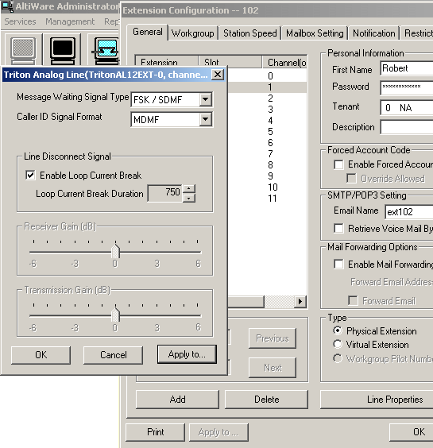
Trouble Shooting:

When my computer reboots, why doesn’t the AltiTouch Plus service start?

See section under “AltiTouch Plus as an NT Service” and also make sure the “Stop attempting to connect to the AltiGen after __ min(s)” is set to a delay long enough for the AltiWare service to start.

How do I remove the AltiTouch Plus service?

To remove the service, first stop the service, then run the application and press the "Uninstall Service" button.

Does the AltiTouch Plus 390 telephone permit an intercom call while person is on the telephone?

No. The AltiTouch Plus phone can receive an intercom call when the callee is not on the phone. The phone will automatically connect and go into speakerphone mode when an intercom call is made to that phone. If the callee is on the phone, the caller will receive a message that this extension is busy, and to please try again later, or that the person at this extension is on the phone and will be with you as soon as possible. The caller should hang-up and try again later.

What happens if my AltiTouch Plus is not connected to a 12 port PCI Analog Station Board?

All the AltiTouch Plus features will work with the exception that the extension cannot be a recipient of an intercom. If the phone is sent an intercom it will respond like a normal call ringing and then going to voicemail if not answered.

How can I increase the volume on the AltiTouch phone?

Using the volume keys located under the dial pad buttons when on the phone will allow you to adjust the volume for that call. However, the volume will go back to its default after hanging up. If the volume is consistently too low or too high, adjust the gain for the volume under the AltiWare Administrator; see your AltiWare Administrator Guide for details.

When I am viewing System Parked Calls under the SysPark+ button, the screen doesn’t update when a new call is parked or picked up by someone else.

In order to see an update on calls that have been system parked on the system, select the “Refresh” soft key prior to making your selection.

I cannot access my voicemail through the VMail+ (Voicemail Plus) soft key, but instead get a warning message.

The VMail+ has a limit of 199 voicemail messages that it can display in either the New or Saved voicemail box. If the number of voicemails exceeds this number when attempting to access VMail+, the phone will display the message:

“Warning! You have
more than 200 msgs.
Please press quit &
use regular vmail to
delete some msgs”.

Press the “Goodbye” button or hang up to exit this screen. Voicemail messages can still be accessed using the “Regular” voicemail soft key, which is found in the Idle State menu screen within the “VMail” soft key. When you have less than 200 voicemail messages stored, you will be able to access them again through the “VMail+” soft key.

When accessing my voicemail through VMail+, I enter my password but I cannot access my voicemail messages on screen.

If you have moved an extension using AltiWare Admin to a different port, you will need to restart AltiTouch Plus in order for it to track this change. This is not required when logging out and logging into an extension through the phone itself. If this isn’t the case, make sure that the AltiGen VM Service is running.

When pressing the VMail+ or the SysPark+ soft keys, the screen displays no information except “Connected to: Unknown name #9401” or “…#9402”.

Check to see that the AltiTouch Plus software on your AltiGen server is running. If it is, and under the Monitor Activity Tab of AltiTouch Plus, it shows users accessing “New Messages” under “Monitor Ports:” and shows calls parked under “Parked Calls:” then check to see that the AltiTouch Plus has been installed in a directory whose path does not contain spaces in the name; for example, do not install it in the program files directory.

For Technical Support:

Contact your AltiGen dealer.



