TECHNICAL BULLETIN
FOR KS TELECOM DEALERS AND DISTRIBUTORS

KSX-32i SOFTWARE UPGRADE

The following is a step by step process detailing the procedure for upgrading the software on a KSX-32i System (Ver. 97.03).

Step 1: Power down KSU and remove the cover.
Step 2: Locate and remove EPROM U5 on the main motherboard.
Step 3: Install new EPROM (supplied by Key System U.S.) in socket U5. Make sure the notch on the EPROM is on the same side as the notch on the socket, and all pins are properly aligned.
Step 4: Verify jumper JP1 is in the 2mg position.
Step 5: Turn dip switch 1 on SW1 to the "OFF" position and power up KSU.
Step 6: Verify system for proper operation and then return dip switch 1 on SW1 to the "ON" position.

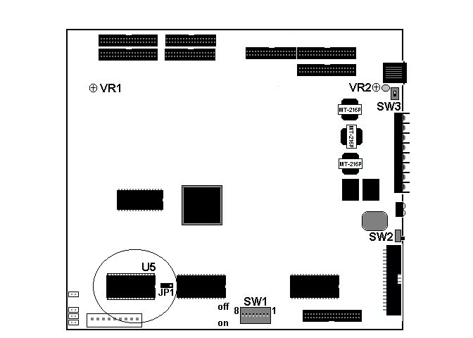
Step 7: Re- program system.

REF:B9081201

