Panasonic
Communication Systems Division
Technical Advisory
Dealer Alert
Updated: Sep 13, 05

Subject: KX-T7775 Doorphone Connection

Document Number: KXT777501

Product and/or Models effected: KX-T7775 Doorphone

Condition:
- There are different connections for the T7775 Doorhone power module depending on which Panasonic KX-T model telephone system you are using.

Connection Options:

- The wiring connections for the Power Module to PBX for all Panasonic models are displayed on the following two pages. The connection to the Power Module is polarity sensitive. The unit would not work if mis-wired.
- This information is described in detail on pages 6 –8 of the Operating Instructions included with the Doorphone.

Panasonic
Communication Systems Division
Technical Advisory
Dealer Alert
Updated: Sep 13, 05

Subject: KX-T7775 Doorphone Connection (cont.)

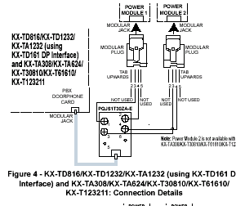

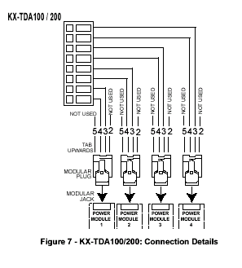

Panasonic
Communication Systems Division
Technical Advisory
Dealer Alert
Updated: Sep 13, 05

Subject: KX-T7775 Doorphone Connection (cont.)

